**Fall 2023 Database Systems (CSCI-3615 - 10344)**

**Assignment 2**

**Ilyas Yagubov**

**1:** **Create schemas.**

**a.Schema for a bookstore will look like this:**

**Books:**

Book_id **(PK)**

Author_id **(FK)**

Title

Num_books

Price

**Author:**

Author_id **(PK)**

Author_name_surname

Author_dob

**Orders:**

Order_id **(PK)**

Customer_id **(FK)**

Order_date

Order_price

**Customers:**

Customer_id **(PK)**

Customer_name

Customer_mail

Customer_phone

**b.** This schema maintains the relationships between books, authors, customers, and orders. The primary keys (PK) are defined for each table to uniquely identify the records within them. The foreign keys (FK) establish relationships between different tables where necessary.

**c.** Establishing foreign key relationships between the tables helps maintain referential integrity. Here are the foreign key relationships in the schema: Books Table: author_id (Foreign Key referencing Author table's author_id) Orders Table: customer_id (Foreign Key referencing Customers table's customer_id)

**d.**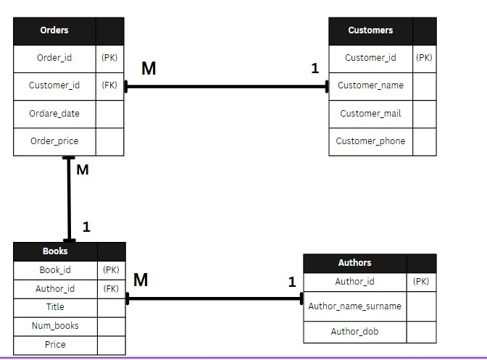

**e.**

-- Create Authors table with serial ID

CREATE TABLE Authors (

Author_id SERIAL PRIMARY KEY,

Author_name_surname VARCHAR(100),

Author_dob DATE

);

-- Create Books table with serial ID

CREATE TABLE Books (

Book_id SERIAL PRIMARY KEY,

Author_id INT,

Title VARCHAR(100),

Num_books INT,

Price DECIMAL(10, 2),

FOREIGN KEY (Author_id) REFERENCES Authors(Author_id)

);

-- Create Orders table with serial ID

CREATE TABLE Orders (

Order_id SERIAL PRIMARY KEY,

Customer_id INT,

Order_date DATE,

Order_price DECIMAL(10, 2),

FOREIGN KEY (Customer_id) REFERENCES Customers(Customer_id)

);

-- Create Customers table with serial ID

CREATE TABLE Customers (

Customer_id SERIAL PRIMARY KEY,

Customer_name VARCHAR(100),

Customer_mail VARCHAR(100),

Customer_phone VARCHAR(20)

);

**2:** **Connect to your database using a Java application.**

1. **I have used jdbc to connect my Java and DataBase and for that I created a specific db_connection.java file code of which is provided below:**

package org.example;

import java.sql.Connection;

import java.sql.DriverManager;

import java.sql.SQLException;

public class db_connection {

private static final String URL = "jdbc:postgresql://localhost:5432/postgres";

private static final String USER = "postgres";

private static final String PASS = "1234";

public static Connection getConnection() throws SQLException {

return DriverManager.getConnection(URL, USER, PASS);

}

}

**3:** **Implement CRUD operations**

This is part of my assignment where I struggled the most I couldn’t make it properly 100% but still tried and created a little program that can store the data that you implement in program to the DataBase that you are connected.